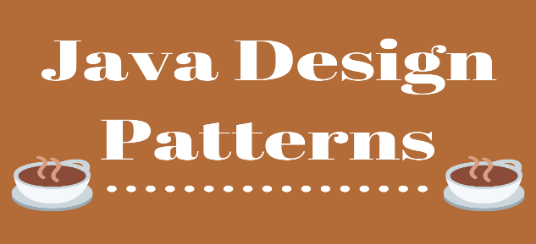

**Types of Patterns**

1. **Creational**: used to simplify the creation of objects to make them more adaptable to different situations.
2. **Structural**: used to connect different parts of an object together, so when a certain part of structure changes the entire part does not need to change.
3. **Behavioral**: used for the interactions/communication between objects, and makes for flexible (loosely coupled) objects.

As always, you want loose coupling and high cohesion when creating objects. Hard coding behavior into your objects is a bad practice and is considered an anti-pattern; something you don’t want to be doing. By following these patterns below, you can write well-designed code.

* Data stored inside the object’s fields often referenced as state, and all the object’s methods define its behavior.
* Class is like a blueprint that defines the structure for objects, which are concrete instances of that class.

**UML:**

